The Friends of the
Racine Public Library*

A group of local citizens, led by a volunteer board, constituted to

- Promote and support Racine Public Library resources and community programs

- Raise funds for the library through
  - Lobby book sales
  - Semi-annual book sales
  - Special events
  - Donations
  - Membership dues

- Promote awareness of vital library services.

- Advocate for adequate library funding at the local, state and national levels.

Benefits of Membership
- Pride in knowing that you are preserving and improving your library
- Members-only access to the semi-annual Book Sales--first choice of materials
- Discounted price for Breakfast with the Authors and other special events
- Coupon for two FREE Lobby Sale books
- Opportunities to lend your talents in support of your library and community

Grants from the Friends

- Support the Summer Reading Program to keep children and teens reading and using the library during their summer break

- Purchase
  - Storytime materials
  - Battle of the Books prizes
  - Books for Babies
  - Big Read materials
  - Innovation Lab materials for those of all ages

- Provide funds for the purchase of Preservation of Racine history films

- Support programming, including
  - Bonk!
  - Ruff Readers
  - Book signings
  - Breakfast with the Author
  - Educational programs for adults

- Provide funding for
  - Dearreader.com email book club service
  - Wi-Fi Hotspots to check out
  - Book Page subscription

To learn more or to volunteer, contact the Library Director, Angela Zimmermann at 262-636-9252 or send an email to friends@rplfriends.org.
Annual Membership Application

Please complete this form and return to the address below.
PLEASE PRINT
Make checks payable to the Friends of the Racine Public Library, Inc., and return to
Racine Public Library, 75 Seventh Street, Racine, WI 53403

Individual $10______
Family $15______ Supporting ($25 or more) $________
Sponsor ($100 or more) $________

Name _______________________________

Address _____________________________

City/State/Zip ________________________

Phone _______________________________

Email _______________________________

Email will only be used by the Friends and will not be shared with other organizations or people.

Optional: You may call me to
- Serve on the board
- Help with book sales
- Prepare mailings
- Provide baked treats for events
- Help in Youth Department
- Distributing information at events
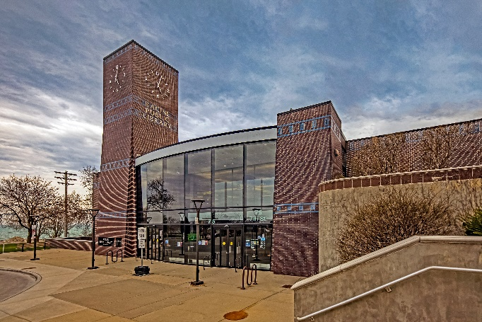

Main Library Hours
Monday - Thursday 9:00 AM – 8:00 PM
Friday & Saturday 10:00 AM – 4:00 PM

Online Communication Center
Monday - Thursday 9:00 AM – 8:00 PM
Friday & Saturday 10:00 AM – 4:00 PM

For Mobile Library Information
call 262-636-9217
or visit http://www.racinelibrary.info/MobileLibrary.htm
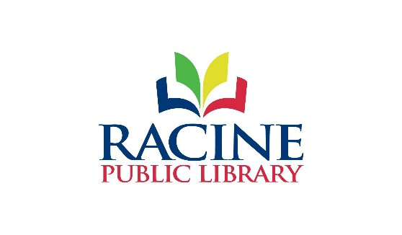
75 Seventh Street, Racine, WI 53403
262.636.9217
http://www.racinelibrary.info
Racine Public Library
A Community Cornerstone

Public libraries possess a unique ability to transform individuals’ lives and guide us to fulfill our potential. Few other institutions are available to all, regardless of your history, identity, age or income – and fewer yet require no membership fee. We strive to be the most universal, accessible space in the community, ensuring our staff’s support and our resources, services and programming are available on all subjects needed.

My wish for this community is that anyone who comes to the library – whether through its doors, mobile services or virtual programs – leaves feeling enriched and rewarded by their visit. Whether it’s by picking up your next favorite read, bringing home tools and recreation to improve your life and community, or connecting with staff to access information on any topic that comes to mind, we’re here to meet your needs.

If you have new ideas or opportunities the library can consider in reaching this goal, I encourage you to reach out to me. The library’s purpose is to aid the community’s constant learning, and that journey must always start from within.

I’ve seen the library’s transformative power every day through the services we offer, the lives we change and the relationships we’re constantly forming. I’m thrilled to welcome you into the library and all that it offers our community.
Angela Zimmermann
Library Director

Contact:
angela.zimmermann@racinelibrary.info
262.636.9252

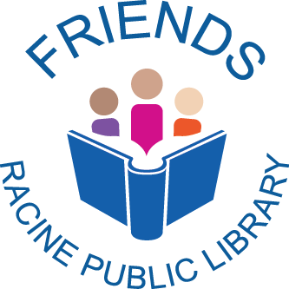

“The only thing that you absolutely have to know is the location of the library”
— Albert Einstein

Membership Invitation

Like us on Facebook!
https://www.facebook.com/
FriendsofRacinePublicLibrary

